EDA Project- using Power BI

By Monika kumari
Retail Sales Analysis

Introduction
The objective of this project is to analyze retail sales data to identify sales trends, customer behaviour, top-performing, products regional and monthly sales performance using Exploratory Data Analysis (EDA) in Excel.

Dataset information
-In Dataset have four different messy table like – customer, product, order and order item
- Each table have multiple duplicate value, null values, consistency category in table

Data Cleaning
-In customer table- all columns correct escape city columns. in city columns remove consistency category through replace method and null values fills with fill down method.
-In orders table-order dates have mix format, clean with use Text to columns in Date method and Payment_method remove consistency or fill null values with fill up method.
-In order item table – Quantity null values fill with 1, unit_price null fill with base prise of product table through apply vlookup function on product id then reminder null values fill average number of unit price columns and finally add column Total Amount (multiple unit price from Quantity columns).
-In product table- remove consistency of category table through replace method.
- and finally remove duplicates from dimension tables and create relation between each table.

Create Dashboard
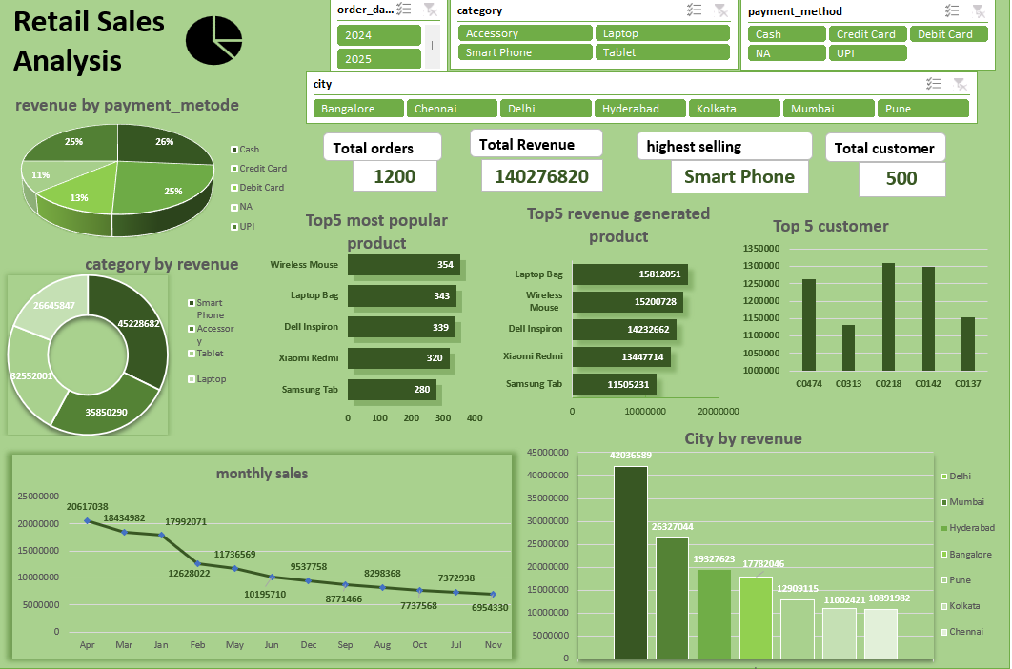

Overview of dataset
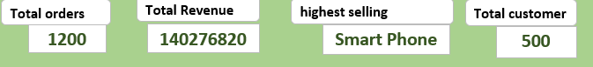
-Total order 1200.
-total revenue 140276820
-highest selling Category is smart phone.
Total customer 500.

Product analysis
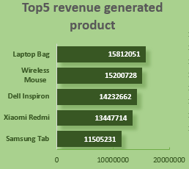
-this is top 5 product name help in high revenue generated
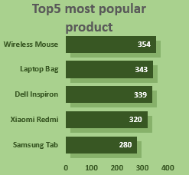
-This is most top 5 popular product name.
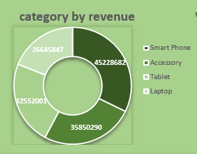
-this revenue by category the most demanding category is smart phone

Sales by Analysis

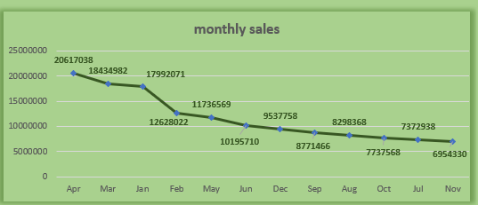

-Monthly sales – in Q1 most selling months but April most selling month of the months.
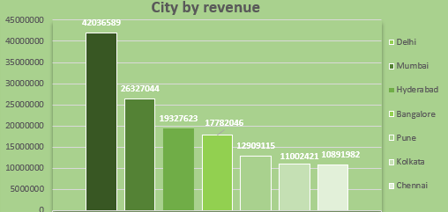
-not use filed map because my excel version is not 365 City by sales Delhi is the most high revenue generated in the city and Kolkata is the very low revenue generated city.

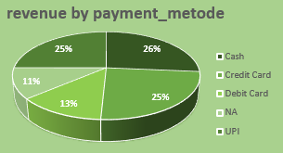
-payment paid mostly credit payment method through.
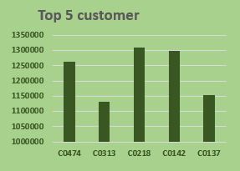
This top 5 customer our dataset,

Insight
-Rethink on service.
-Improve Quality of product,
-In west Bengal advertise and organize camping of product.

Conclusion
-laptop bag is the most high revenue generated product but wireless mouse is most demanding product.
-in category smart phone is most revenue generate.
- Delhi is the most high revenue generated city and Kolkata is very low.
-Q1 in most revenue generated months but Aprils is the most high revenue generated months.
-amount pay mostly credit card method.

